About Google Scholar
Google Scholar (scholar.google.com) provides a simple way to broadly search for scholarly literature. From one place, you can search across many disciplines and sources: articles, theses, books, abstracts and court opinions, from academic publishers, professional societies, online repositories, universities and other web sites. Google Scholar helps you find relevant work across the world of scholarly research.

How it relates to Gale, A Cengage Company

Google Scholar is considered a Discovery Service by Gale. Search Results from Google Scholar may have links to access the document directly in Gale online products. Gale shares the following collections with Google for participation in Scholar: Gale Academic OneFile, Gale OneFile: Health and Medicine, Gale OneFile: Informe Académico, and Literature Resource Center. By indexing Gale content, users can retrieve this content within the Google Scholar interface. Gale content is exposed to users three different ways: Feature Links, Version Links, and Library Links.

Feature Links
While Google Scholar indexes Gale content, it determines if the article is unique (meaning the article is not indexed by another source in its knowledge base). If the article is unique then the feature link will go directly to Gale. The Feature Link is the article title of the citation.

Version Links
If the document is already indexed in Google Scholar, then the link to Gale becomes a Version Link. Version Links are links to all other sources that contain the full text of the article. The Version links are located below the citation with the link label as “All X versions” (where X is the number of version links). When an article is indexed directly from the publisher, then it will always be favored as the feature link.

Library Links
In addition to Feature Links and Version Links, libraries may opt to set up Library Links, which are article-level links to subscription full text for patrons affiliated with a library. When a user searches Google Scholar and a Gale result is found, then a link to Gale will appear. Library Links to Gale products will display “[HTML] gale.com.” or “[HTML] galegroup.com.”
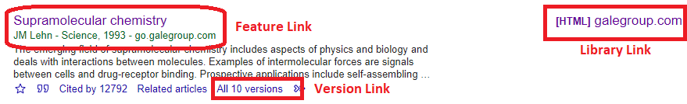

Authentication

If the user is authenticated via a known institution IP address, then that user can view the full text of the article. If the user has successfully logged into Gale in a previous session and has a valid cookie, then Gale will automatically authenticate the user and allow access.

In 2018, Gale started participating in a feature within Scholar called CASA. This presents a mechanism to enable seamless off-campus and mobile access for subscribed users.
Off-campus users can self-select their affiliation by performing the following steps:
- Go to https://scholar.google.com/
- Click on “Settings”
- Click on “Library Links”
- Search for the name of your library
- Select the checkbox next to the name of the appropriate library, then choose “save”

Enrolling your library in the Scholar program

You can enable Google Scholar within GaleAdmin using the steps outlined below. Note that it can take up to 4 weeks for your library to appear in Google Scholar.
- Login to GaleAdmin at http://admin.gale.com
- Click View/Edit next to the location that you want to enable
- Click on "Preferences", then choose "General Preferences"
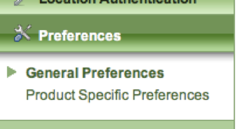
- Scroll down to “Enable Google Scholar” and check the “Yes” button
- Scroll to the bottom and click “Save”

You also need to verify that your IP addresses are configured correctly. Google Scholar requires that IP address are assigned to location ids. This creates a one-to-one mapping of location id to IP address. The following steps will ensure that your IP addresses are assigned properly.
Note that not all customers have the permission to view these settings. If you cannot view these settings, please contact Gale Technical Support for assistance. If you are located in the US or Canada, you can contact support at gale.technicalsupport@cengage.com or 800-877-4253. Libraries in all other countries can find contact information at http://www.gale.com/world

- Login to GaleAdmin at http://admin.gale.com
- Click View/Edit next to the location that you want to enable
- Click on the blue "Institution” tab at the top
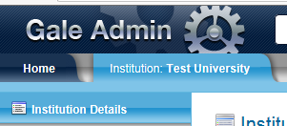
- Click on "Institution Authentication", then choose "IP Addresses"
- Find your libraries IP addresses in this list. Caution: You may be able to see/modify other library IP addresses on this page. Do not modify IP addresses that are not yours.
- Look at the location name column. If this says “Assigned to all locations” then you need to assign your IP addresses. You can do this by choosing your library name in the drop down, then scrolling down to choose “Save.” In the screenshot below, the first IP address range is assigned, while the second is not.

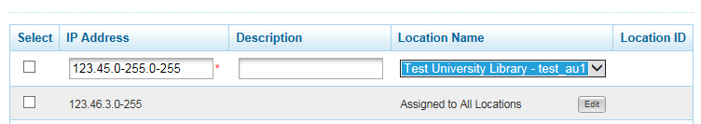

FAQs
- What Gale collections are supported through Google Scholar.
Gale Academic OneFile, Gale OneFile: Health and Medicine, Gale OneFile: Informe Académico, and Literature Resource Center.

- Is all content from Gale supported products indexed by Google Scholar?
No. Only content that is full-text and has an academic focus,is shared with Google for inclusion in Scholar. Gale also allows for publishers to individually opt out if they do not wish to participate in Google Scholar.

- Where can I find additional information about Google Scholar?
https://scholar.google.com/intl/us/scholar/libraries.html

- How can I verify that the links to Gale material are appearing in Google Scholar?
If you execute the following search within Google Scholar, it will limit your results to only show results for Gale content. Please note that this query will NOT display the complete data set of Gale content that is indexed in Google Scholar.
Search query = site:go.gale.com

