August 2024
LTI 1.3 Admin Install Guide

*Please Note: Only a single LTI 1.3 tool may be configured as a provider. Each Gale database will need to be added individually as a placement.

As an administrator, login to Administrator Tools and under Integrations select LTI Tool Providers
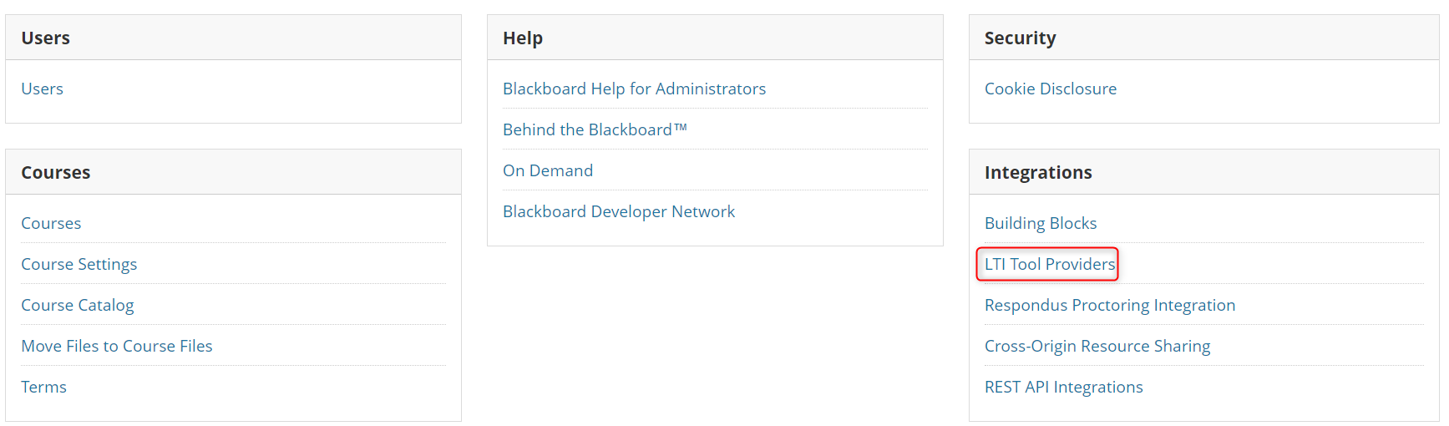

On the LTI Tool Providers page, select Register LTI 1.3/Advantage Tool
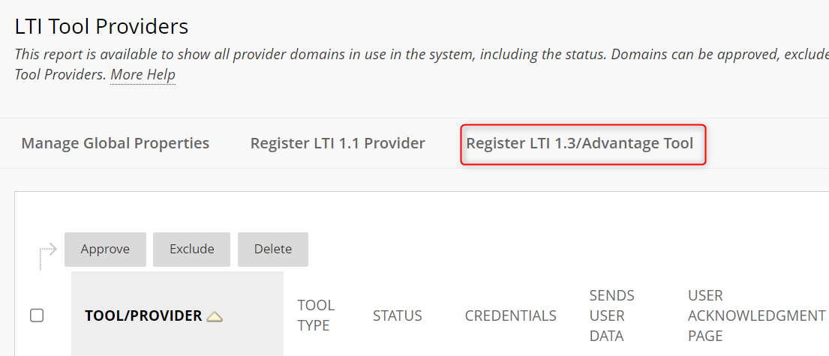

On the following page, fill the listed fields as below:

Client ID: 58b02c8a-77f2-4700-a99f-905a7fc96016
Name: Gale LTI 1.3 Tool
Description: (Optional)
Initiate Login URL: https://link.gale.com/apps/lti/initLogin
Tool Redirects URL: https://link.gale.com/apps/lti/launch
JWKS URL: https://link.gale.com/apps/lti/security/jwks
Domains: link.gale.com
Tool Provider Custom Parameters
lms_name=blackboard
location=Your Location ID or Consumer Key (Contact Technical Support if you are unsure what this value may be)
secret=Your Shared Secret (Contact Technical Support if you are unsure what this value may be).
Your results should resemble the example below.
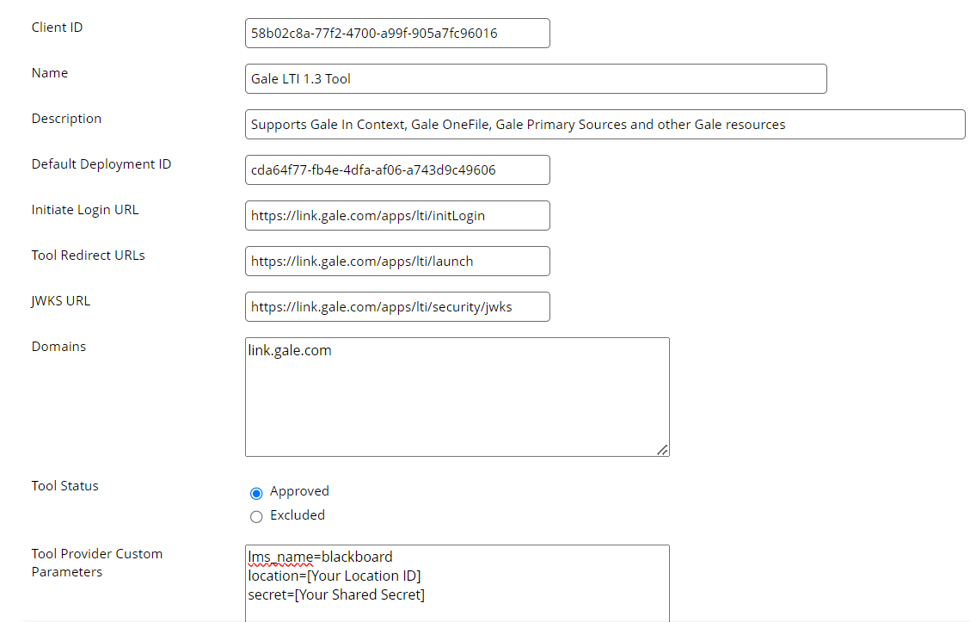

Once you have submitted and approved the integration, you will be prepared to setup individual Gale resources and placements.

Gale Placement Setup

To add an individual Gale resource, from your LTI Tool Providers page, scroll to Gale LTI 1.3 Tool, select the arrow next to its name, and choose Manage Placements
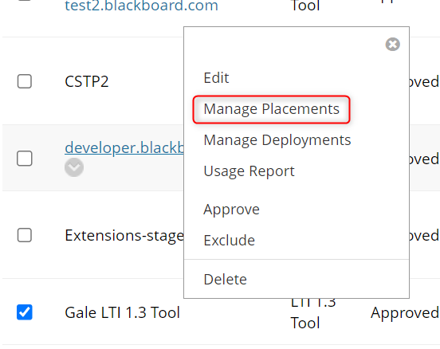

On the Manage Placements page, then select Create Placement
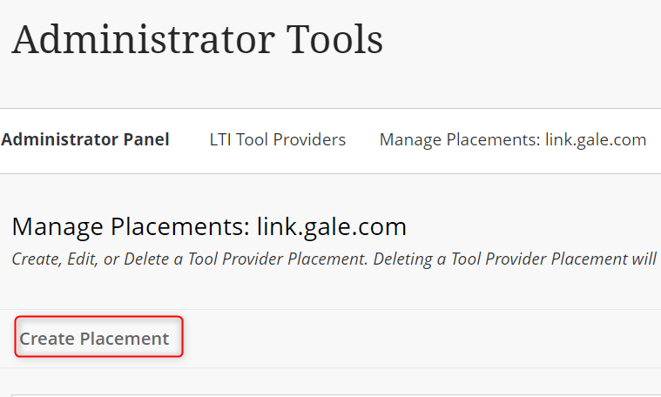
Provide a name and description for the new placement, such as the name of the database and its function.
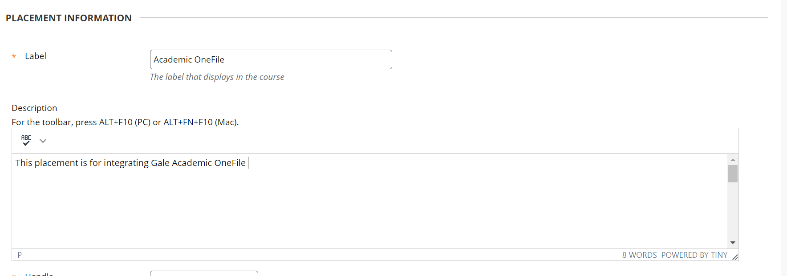
Ensure a unique Handle is set, that Availability is set to “Yes” and Deep Linking content tool and Allow student access are enabled.
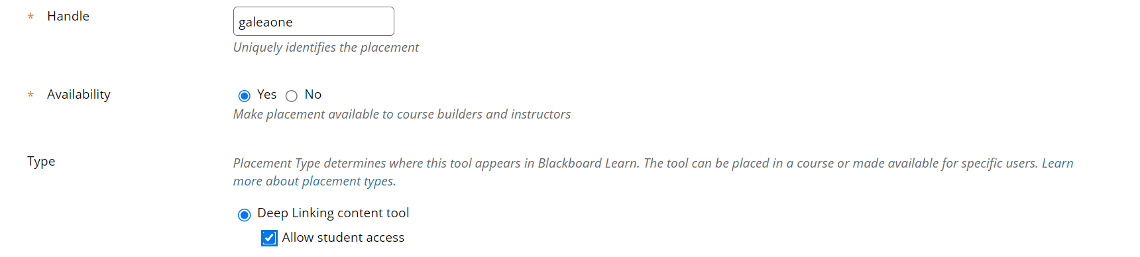

Under Tool Provider Information fill the listed fields as below:

Target Link URI: https://link.gale.com/apps/lti/launch
Tool Provider Custom Parameters
product=Database product ID (If you are unsure of a database’s product ID, please navigate to https://support.gale.com/urls/ and enter your Location ID to view a full list of your products and their product IDs.)

Please note: Not all Gale databases are LTI certified and support deep linking, to see a list of certified Gale databases, visit https://support.gale.com/doc/lmsinstall-urls, third party databases such as Udemy, Peterson’s and Miss Humblebee’s Academy do not support placement functionality.
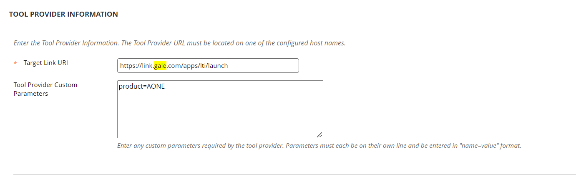

Once the placement is submitted, the resource will be available for instructor user.

