Social Media Posts
Always include your library’s web page with information on how to access Miss Humblebee’s Academy or the Miss Humblebee’s Academy access page itself. Shorten links with bit.ly, if needed.
 | POST COPY/TEXT | Facebook | Twitter
1 | We can help prepare your preschooler for kindergarten and beyond! Miss Humblebee’s Academy is a fun and interactive learning program for children ages 3 to 6. Access it here <link to access> | Yes | No
2 | Are you worried about your child being ready for kindergarten? Miss Humblebee’s Academy can get them on the right path and give you weekly progress reports. <link to access> | Yes | No
3 | Early literacy lessons in Math, Science, Social Studies, Language Literacy, Art, & Music, try Miss Humblebee’s Academy today! <link to access> | Yes | Yes
4 | Pre-k kiddos can have fun AND learn with Miss Humblebee's Academy. <link to access> | Yes | Yes
5 | Head, shoulders, knees, and toes…knees and toes. Learn the parts of the body with Miss Humblebee’s Academy <link to access> | Yes | Yes
6 | Education + Smiles = Effective Learning. Miss Humblebee’s Academy assists pre-k learners in building foundational learning skills. <link to access> | Yes | No
7 | Access a fun and interactive learning program for children ages 3 to 6 through our library. Try Miss Humblebee’s Academy! <link to access> | Yes | No
8 | Miss Humblebee’s Academy is an easy to use educational tool to pre preschooler’s for kindergarten and beyond. See what it has to offer <link to access> | Yes | No
9 | With Miss Humblebee’s Academy, kindergarten prep is fun and measurable, at home, or on-the-go. <link to access> | Yes | Yes
10 | Miss Humblebee’s Academy is the only solution that helps children learn while having fun AND provides parents with tools to measure their child’s progress. <link to access> | Yes | No

Images:
Post 4:
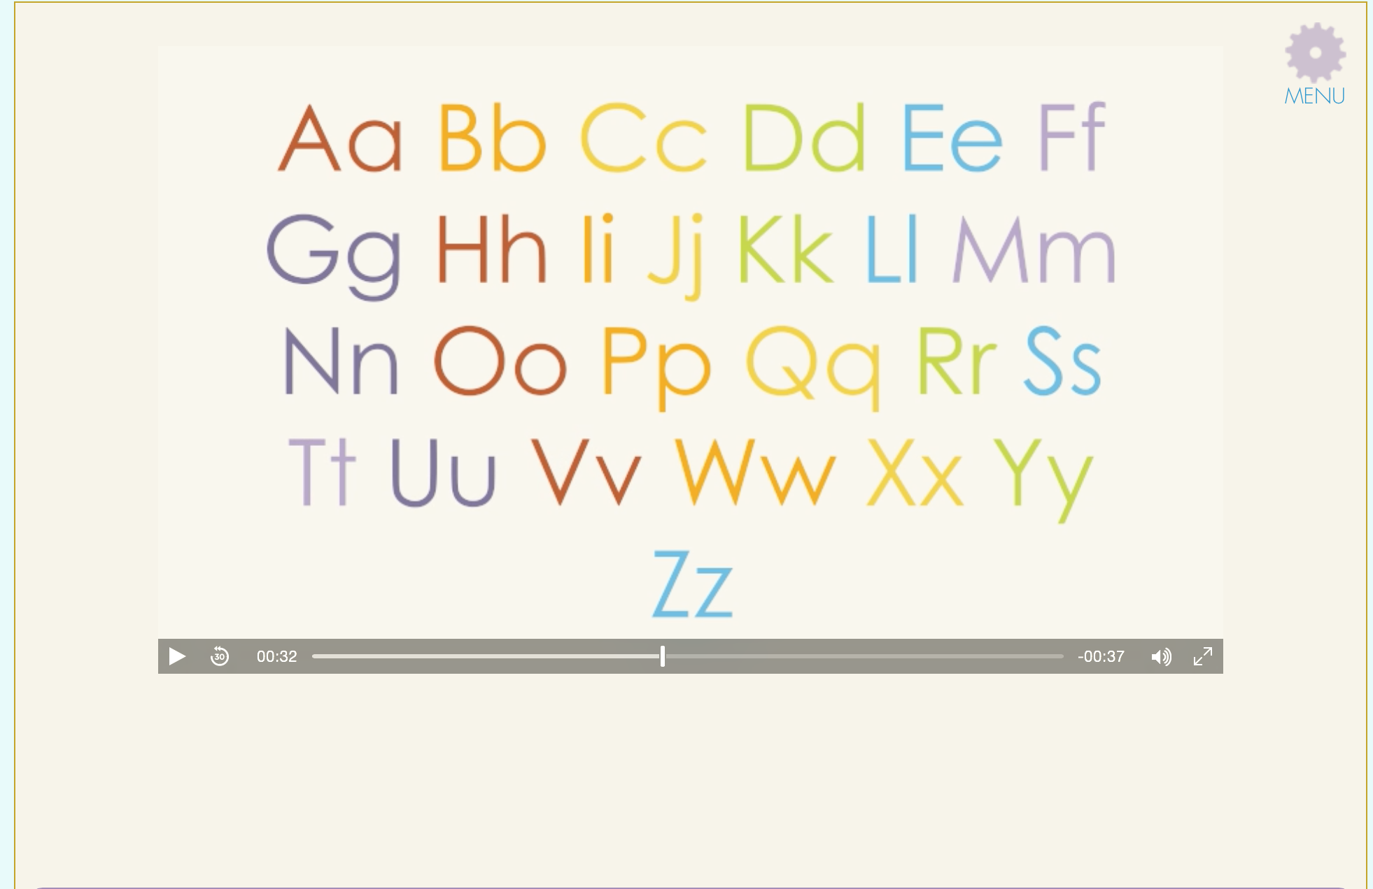
Post 5:
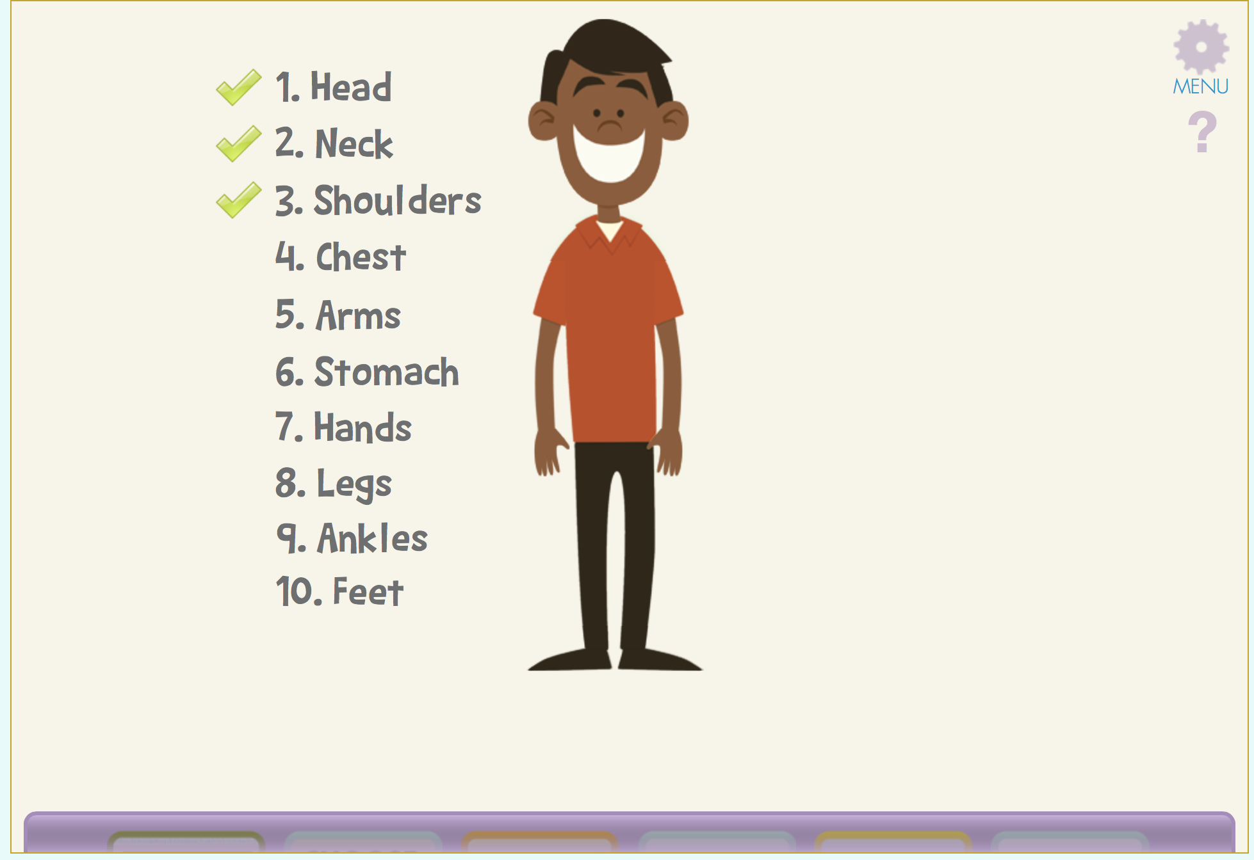
Applicable to all posts:
