Gale’s Homework Help Resources
Primary Audience: Students
Secondary Audience: Teachers and Parents

How to Use: (1) Copy and paste the description into your Facebook or Twitter page. (2) Include a social media image with each post. (3) Link to your Homework Help Resources page. You can shorten the link with bit.ly.

How to Display:
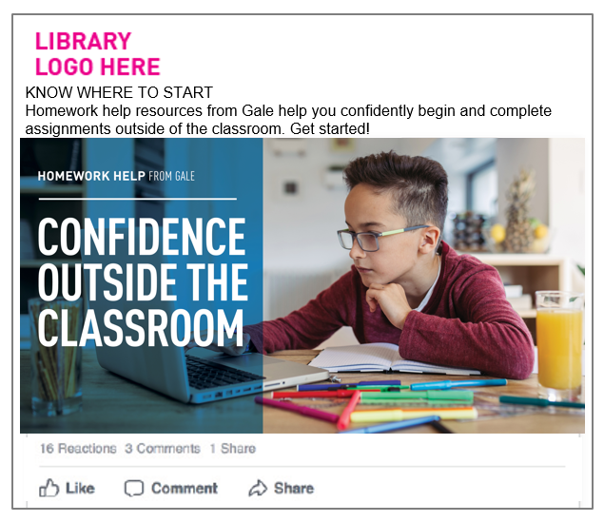

 | POST COPY/TEXT | Facebook | Twitter*
1 | KNOW WHERE TO START  Homework help resources from Gale help you confidently begin and complete assignments outside of the classroom. Get started! <link to access> | Yes | Yes  w/o headline
2 | START SCHOOLWORK WITH CONFIDENCE  OR  CONFIDENCE OUTSIDE THE CLASSROOM  Have an assignment? Get quick access to credible sources covering topics taught in class. Access now. <link to access> | Yes | Yes  w/o headline
3 | Homework help resources give you quick access to credible sources—and with integrated tools, you can save and share content. Start now!  <link to access> | Yes | Yes
5 | Have an assignment? Get homework help. Access credible sources with integrated tools that let you share, save and download content. <link to access> | Yes | Yes
6 | Homework help resources offer access to credible sources, and with integrated tools like G Suite for Education, you can save content. <link to access> | Yes | Yes
7 | Have an assignment? Know where to start. Access homework help resources from Gale for credible sources that align with classroom topics. <link to access> | Yes | Yes

*As of November 2017, tweet character counts have risen from 140 to 280, although readership is higher if tweets stay short.

