Gale In Context: Elementary
Social Media Posts
Primary Audience: Parents
Secondary Audience: Teachers

How to Use: (1) Copy and paste the description into your Facebook or Twitter page.
(2) Add a hyperlink to your library’s website or Gale In Context: Elementary product page. Shorten the link with bit.ly, if needed.

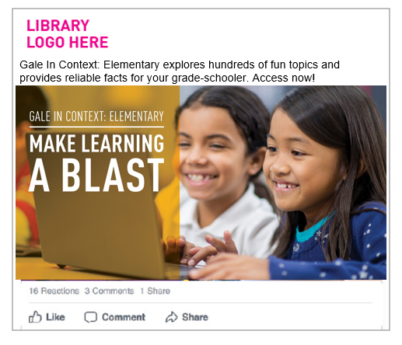
How to Display:
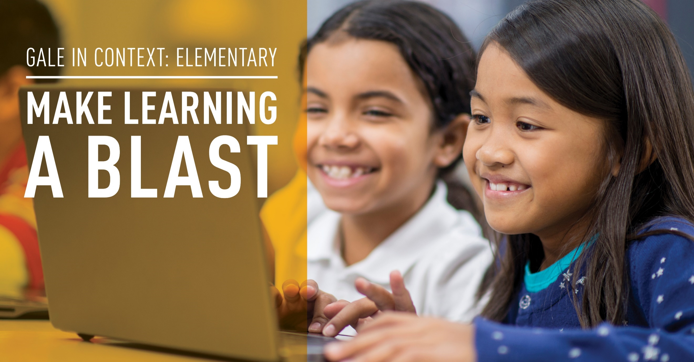

 | POST COPY/TEXT | Facebook | Twitter
1 | MAKE LEARNING A BLAST  Gale In Context: Elementary explores hundreds of fun topics and provides reliable facts for your grade-schooler. Access at <hyperlink to your library’s website or Gale In Context: Elementary product page> | Yes | Yes w/o headline
2 | Does your child have an assignment on their favorite hero? Gale In Context: Elementary makes searching for credible information easy. Find results at <hyperlink to your library’s website or Gale In Context: Elementary product page> | Yes | Yes
3 | I wonder how killer whales got their name? Find out with Gale In Context: Elementary—a safe source for grade-schoolers to do all kinds of research. Go exploring. <hyperlink to your library’s website or Gale In Context: Elementary product page> | Yes | Yes
4 | Gale In Context: Elementary helps elementary students research everything from rhinos to rainbows. Access this kid-friendly source at <hyperlink to your library’s website or Gale In Context: Elementary product page> | Yes | Yes
5 | HOMEWORK CHALLENGE: I wonder if I can see Jupiter without a telescope? Help your child find the answer at <hyperlink to your library’s website or Gale In Context: Elementary product page> | Yes | Yes
6 | HOMEWORK CHALLENGE: Does your grade-schooler know <NAME OF STATE>’s state flower? Watch your child’s interest in research blossom with Gale In Context: Elementary. <hyperlink to your library’s website or Gale In Context: Elementary product page> | Yes | Yes
*As of November, 2017, tweet character counts have risen from 140 to 280, although readership is higher if tweets stay short.

